Intelligent Cubic Player:

Tic-Tac-Toe 3D Project idea
Intelligent Cubic Player for Tic-Tac-Toe 3D
The intelligent cubic player is a sophisticated AI program designed to play the game of Tic-Tac-Toe in a three-dimensional space. It utilizes advanced algorithms such as the Minimax Algorithm, Alpha-Beta Pruning, and Heuristic functions to make intelligent and strategic moves.
The purpose of the intelligent cubic player is to provide a challenging and engaging opponent for players of Tic-Tac-Toe 3D. It is capable of analyzing the game board, predicting future moves, and making optimal decisions based on the current state of the game.
With its advanced algorithms, the intelligent cubic player can adapt to different playing styles and strategies. It is designed to provide a fair and competitive gaming experience, ensuring that players are constantly challenged and engaged

Game Overview to 3D Tic-Tac-Toe

Rules

Tic-Tac-Toe 3D is a game played on a 3x3x3 grid, with two players taking turns to place their markers in an attempt to create a line of three markers in any direction: horizontally, vertically, diagonally, or even across different layers of the grid.

Objectives

The objective of the game is to be the first player to create a line of three markers in any direction. The line can be horizontal, vertical, diagonal, or even across different layers of the grid. The game ends when one player achieves this objective or when the entire grid is filled with markers and no player has won

HOW TO WIN
Here are the specific rules:
Rows:
A player wins if they have four marks in a row on any horizontal row that spans across all layers.
A player wins if they have four marks in a row on any vertical row that spans across all layers.
A player wins if they have four marks in a row on any diagonal row that spans across all layers.
Columns:
A player wins if they have four marks in a row on any column that spans across all layers.
A player wins if they have four marks in a row on any diagonal column that spans across all layers.
Diagonals:
A player wins if they have four marks in a row along any diagonal that connects different layers.
The winning conditions are more complex due to the three-dimensional nature of the board.
Players need to strategize across layers, rows, and columns to achieve victory.
The game ends when one player successfully forms a line of four marks in any of the specified directions.
If the entire board is filled without a winner, the game is a draw.
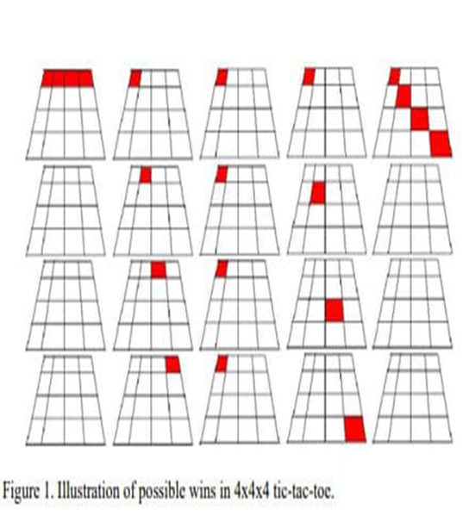

application similar to 3D Tic Tac Toe 4*4*4
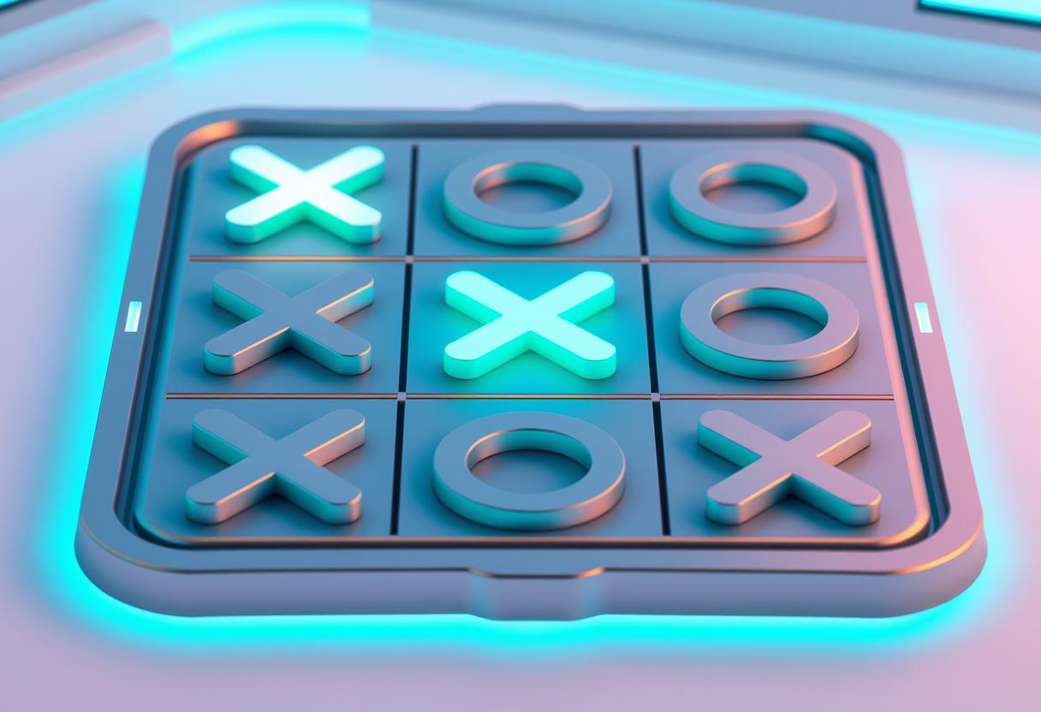
XO Game | Tic Tac Toe

Cubic — 3D tic tac Toe

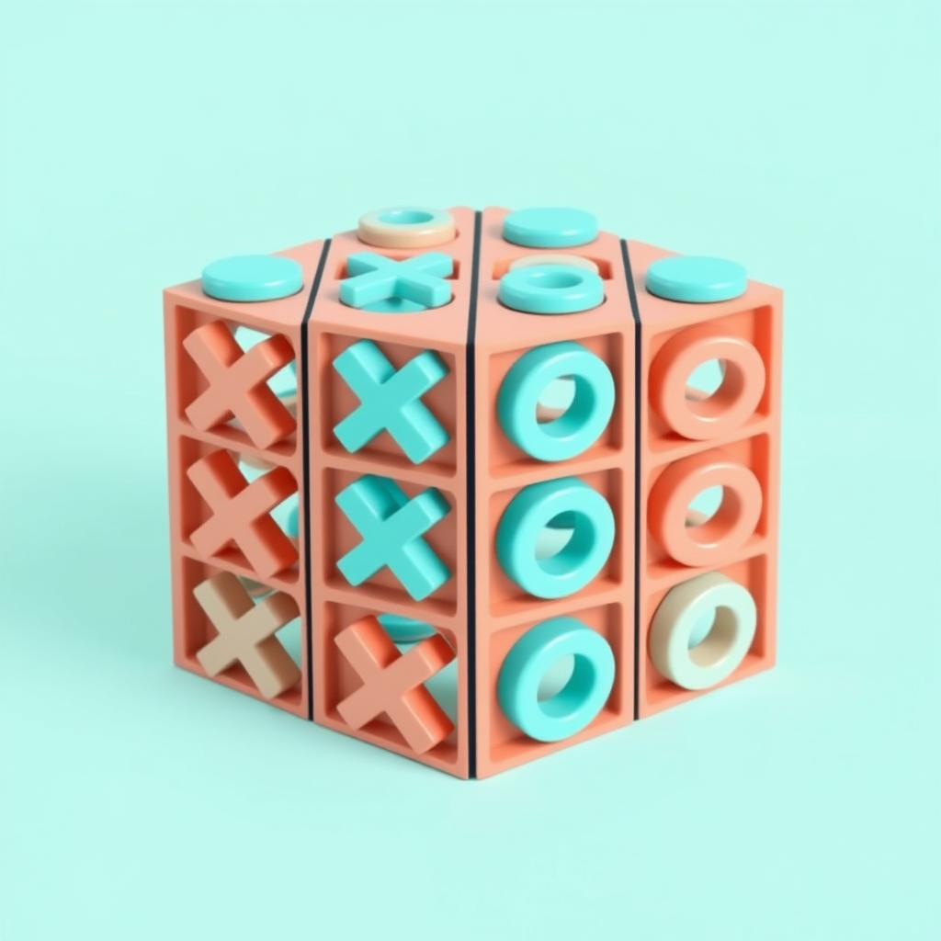

Some of books and articles relevant to this game
-Android Application Development and Implementation 3 Dimensional Tic-Tac-Toe for Danial C. Hanson Department of Computer Science – Ripon College
-Artificial Intelligence: Implementing 3D Tic-Tac-Toe in C++ for
Bradley D. Bogenschutz Department of Mathematics
and Computer Science – Ripon College
- APOS Theory as a Conceptualization for Understanding
Mathematical Learning for
Sarah R. Weyer Department of Mathematics and Computer Science – Ripon College
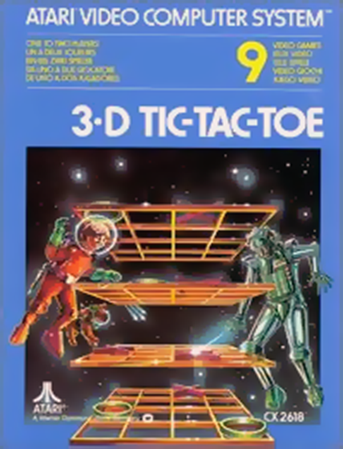
Microsoft Word - D. Hanson - Android 3D TTT.doc (ripon.edu

3D TIC TAC TOE
In ordinary tic-tac-toe with nine squares, if both players know how to play, the game should tie, right?
This means that there is no winning strategy for either player. In tic-tac-toe 3x3x3 or even 4x4x4, this doesn't happen. There is a winning strategy for the first player.
This means that if the first player knows the strategy he will win. No matter what the second player does, he will know how to respond and will win in the end. Can you figure out how to always win on the 3x3x3 board? And on the 4x4x4 board? In fact, one of the cases is much more difficult than the other!

3D TIC TAC TOE | MATEMATECA (usp.br)
In the next images, photographed by Rodrigo Tetsuo Argenton, we have an example of a game on the 3x3x3 board and one on the 4x4x4 board. Would you make the same moves or know a better strategy?
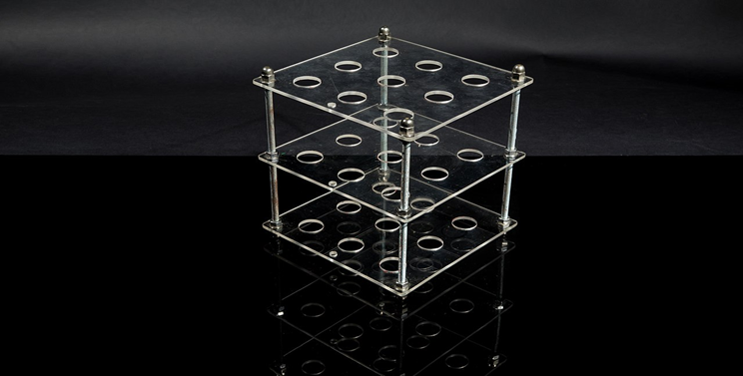
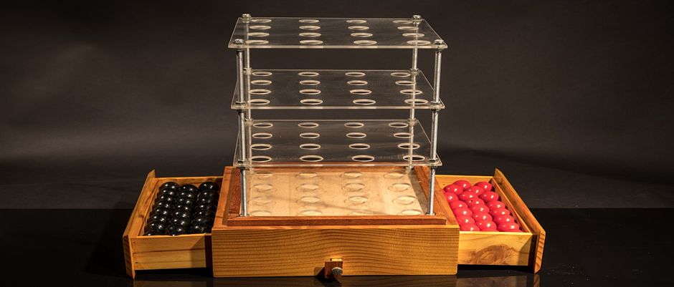

algorithms that used in this game

minimax Algorithm
he Minimax Algorithm is a decision-making algorithm used in the intelligent cubic player for the Tic-Tac-Toe 3D game.
The algorithm evaluates all possible moves in the game and assigns a score to each move based on the current state of the game.
The goal of the algorithm is to maximize the score for the AI player and minimize the score for the opponent player.
The algorithm uses a recursive approach, exploring the game tree by considering all possible moves and their outcomes.
At each level of the game tree, the algorithm alternates between maximizing and minimizing the score.
The algorithm assumes that the opponent player will make the best possible move, and the AI player will make the best move based on that assumption.
The algorithm continues to explore the game tree until it reaches a terminal state, such as a win, loss, or draw.
Once the algorithm reaches a terminal state, it assigns a score to that state based on the outcome of the game.
The algorithm then backtracks and propagates the scores up the game tree, making decisions based on the highest or lowest scores.
By using the Minimax Algorithm, the intelligent cubic player can make optimal decisions in the Tic-Tac-Toe 3D game.

algorithms that used in this game

Alpha-Beta Pruning
Enhancing Performance
The Alpha-Beta Pruning technique improves the performance of the intelligent cubic player by reducing the number of nodes that need to be evaluated in the game tree.
Efficient Search
By using Alpha-Beta Pruning, the intelligent cubic player can efficiently search through the game tree, avoiding unnecessary evaluations of nodes that are guaranteed to be worse than previously evaluated nodes.
Cutting Off Unpromising Branches
The Alpha-Beta Pruning technique allows the intelligent cubic player to cut off branches of the game tree that are determined to be unpromising, further reducing the number of nodes that need to be evaluated.

Heuristic Functions
Heuristic reduction
heuristic reduction in AI algorithms involves using heuristics as guiding strategies to simplify and accelerate the problem-solving process. It's a valuable approach for dealing with complex problems where exhaustive search may not be feasible, and quick decision-making is essential.
Evaluation Function
The evaluation function is a heuristic function used to evaluate the current state of the game and assign a score to it. It takes into account various factors such as the number of winning lines, the number of occupied cells, and the potential for future wins. The higher the score, the more favorable the position is for the intelligent cubic player.
Symmetry reduction
symmetry reduction in AI algorithms involves identifying and exploiting symmetrical properties within a problem to streamline the search process. It is a valuable technique to reduce redundancy, improve computational efficiency, and accelerate the algorithm's performance, especially in domains where symmetry is prevalent.
A* Search
A* Search is a popular algorithm used in AI for finding the shortest or most efficient path between two points. It’s especially useful in situations like pathfinding in games or maps, where you want to reach a goal as quickly and efficiently as possible.

DIAGRAMS
1)BLOCK DIAGRAM
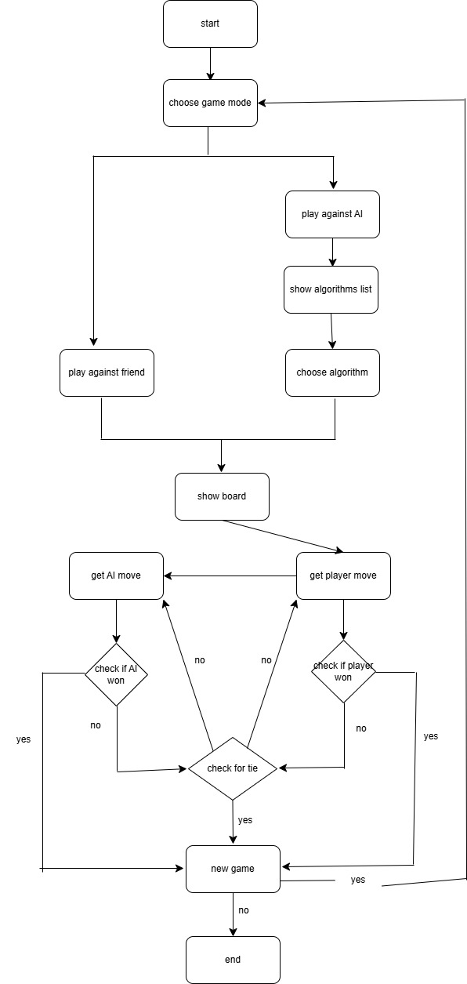

DIAGRAMS
2)USE CASE ( UML )
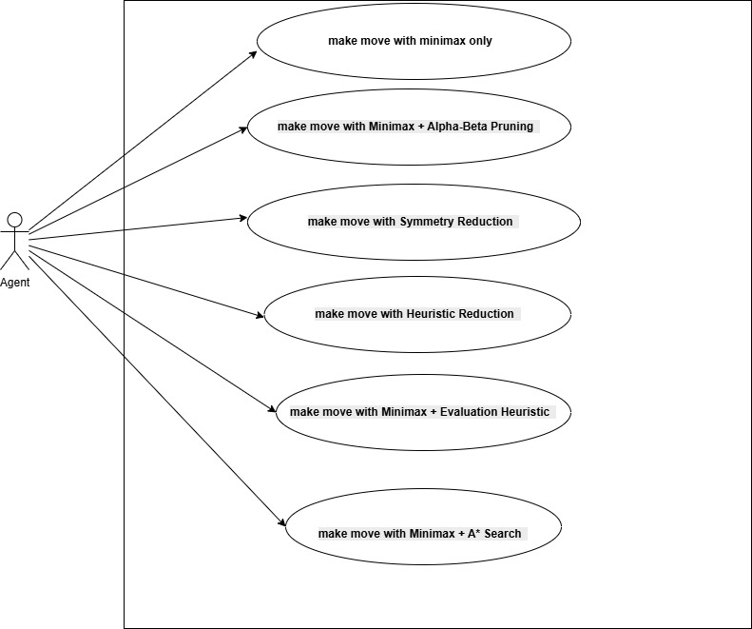
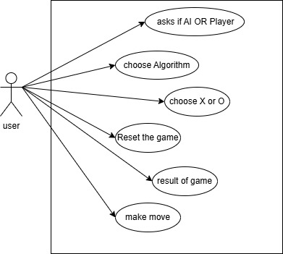

FLOW CHARTS ( for USER)
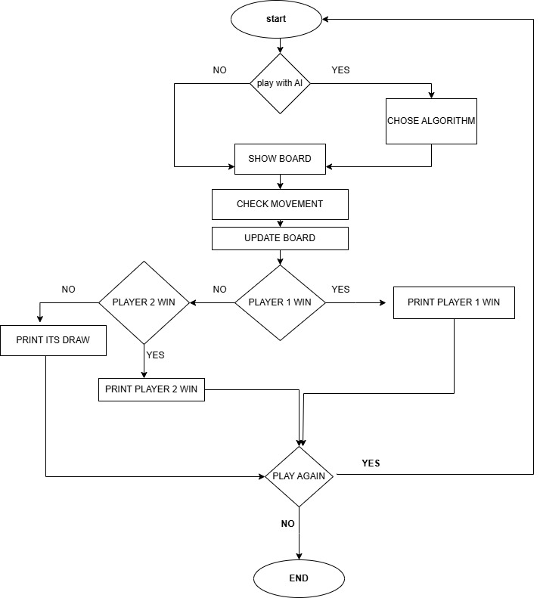

FLOW CHARTS ( MiniMax algorithm with heuristic reduction)
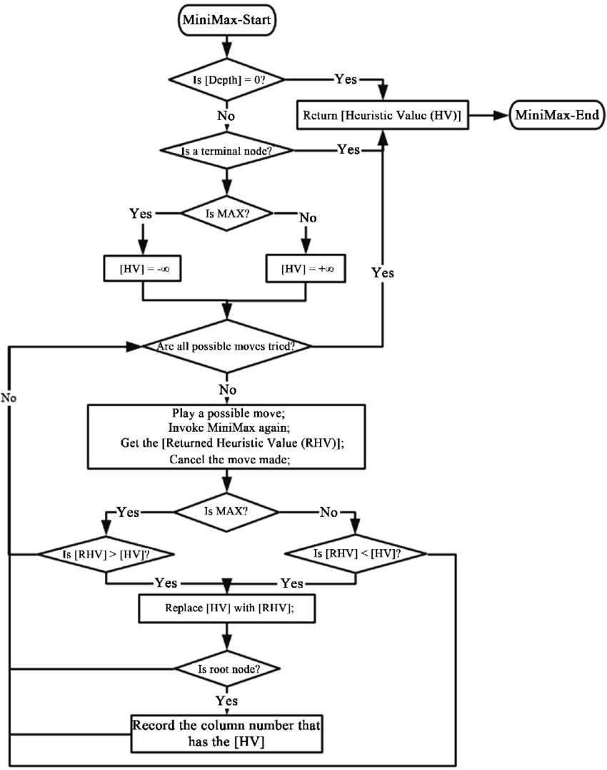

FLOW CHARTS ( MiniMax algorithm with symmetry reduction)
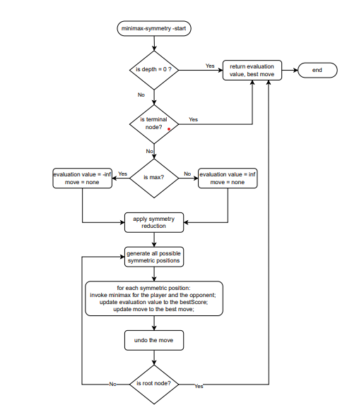

FLOW CHARTS ( alpha beta_pruning algorithm)
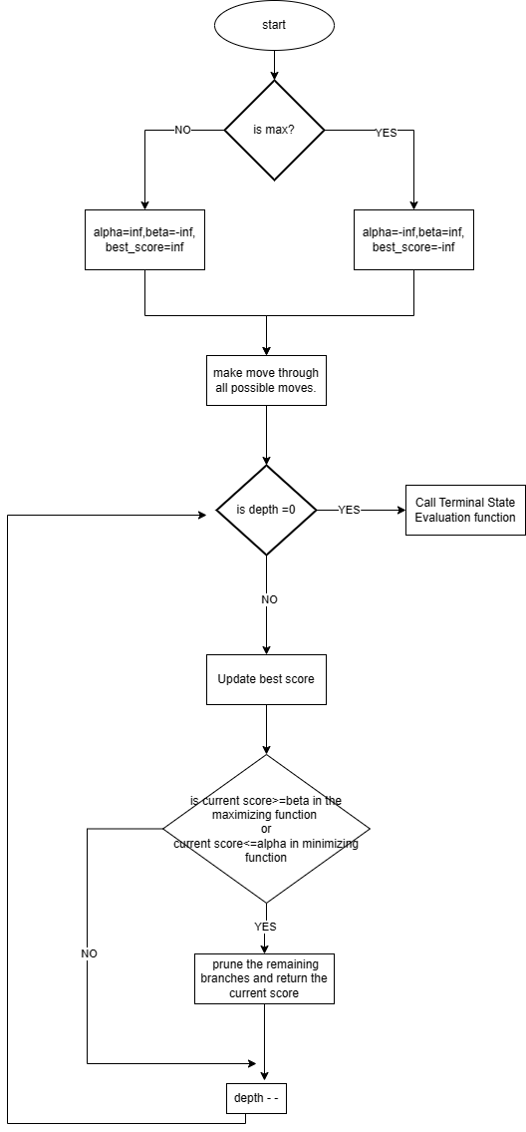

Activity diagram
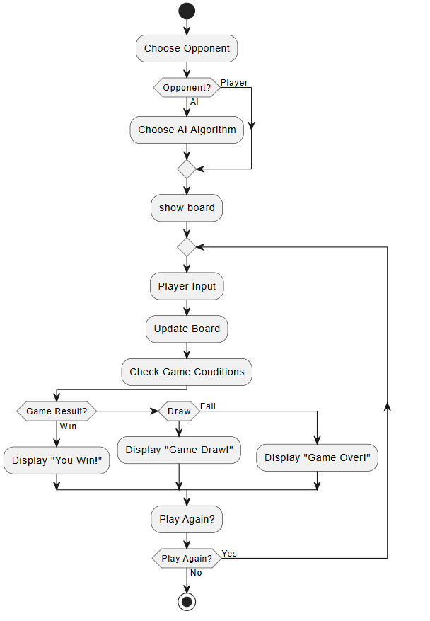

Conclusion

In conclusion, the intelligent cubic player for the Tic-Tac-Toe 3D game is a powerful tool that utilizes the Minimax Algorithm, Alpha-Beta Pruning, and Heuristic functions to enhance gameplay and provide an optimal strategy for players.
By analyzing all possible moves and their outcomes, the intelligent cubic player can make informed decisions and choose the best move to maximize the chances of winning.
The benefits of using the intelligent cubic player include:
- Improved gameplay experience with challenging and strategic moves.
- Enhanced decision-making skills for players by providing insights into optimal moves.
- Increased chances of winning by choosing the most advantageous moves.

